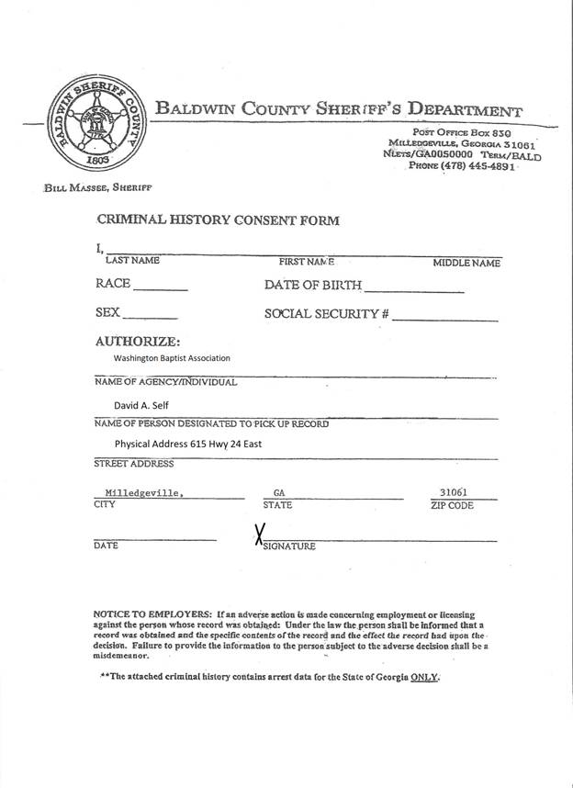

Dr. Jerry Pickard, Interim Director of Missions